Solution Definition

Copyright © 2023, Oracle and/or its affiliates

NHS SCCL’s – Engine for Validation of Awards
Eva – Pilot Project

17th of March 2025 | Version 2.2

Contents
Document Control 4
1.1 Version Control 4
1.2 Team 4
1.3 Document Purpose 4
Business Context 5
2.1 Executive Summary 5
2.2 Workload Business Value 6
2.3 Overview 6
2.4 Functional and Non-Functional Requirements 6
2.4.2 Regulations and Compliances Requirements 7
2.5 Environments 7
2.6 Future State Architecture: 8
2.6.1 Mandatory Security Best Practices 9
2.6.2 Logical Architecture 10
2.6.3 Physical Architecture 13
2.7 Solution Considerations 13
2.7.1 High Availability and Disaster Recovery 13
2.7.2 Security 14
2.7.3 Networking 14
Sizing and Bill of Materials 15
Project Implementation (Only for Oracle Implementations!) 15
4.1 Solution Scope 15
4.1.1 Disclaimer 15
4.1.2 Overview 15
4.1.3 Business Value 16
4.1.4 Success Criteria 16
4.2 Workplan 16
4.2.1 Deliverables 16
4.2.2 Included Activities 16
4.2.3 Recommended Activities 18
4.2.4 Timeline 18
4.2.5 Implementation RACI 19
4.2.6 Assumptions 20
4.2.7 Obligations 20
4.2.8 Transition Plan 21
Annex 21
5.1 Security Guidelines 21
5.1.1 Oracle Security, Identity, and Compliance 21
5.1.2 Compliance and Regulations 22
5.2 Additional Resources 22
5.3 Networking Requirement Considerations 22
5.3.1 Application Connectivity 22
5.3.2 DR and Business Continuity 22
5.3.3 High Availability and Scalability 23
5.3.4 Security and Access Control 23
5.3.5 Monitoring and Troubleshooting 23
5.4 Networking Solutions 23
5.4.1 OCI Network Firewall 23
5.4.2 OCI Load Balancer 23
5.4.3 OCI DNS Traffic Management 23
5.4.4 OCI WAF 24
5.4.5 OCI IGW 24
5.4.6 OCI Site-to-Site VPN 24
5.4.7 OCI Fast Connect 24
5.4.8 OCI VTAP 24
5.4.9 OCI NPA 24
5.4.10 OCI DRG (Connectivity Options) 24
5.4.11 OCI Oracle Cloud Infrastructure Certificates 25
5.4.12 OCI Monitoring 25

Guide:
Author Responsibility
- Chapter 1-3: Sales Consultant
- Chapter 4: Implementer

Document Control

Version Control

Version | Authors | Date | Comments
1.0 | Base Template | 1st June 2023 | Template used
1.1 | Solution Design | 17th March 2025 | Updated Solution Design document
2.0 | Pankaj Sharma | 18th April 2025 | Updated Solution Design document
2.1 | Vasudeva Manikandan | 5th May 2025 | Updated Lift Implementation Section
2.2 | Vasudeva Manikandan | 22nd May 2025 | Updated Lift Implementation Section
2.3 | Vasudeva Manikandan | 23rd May 2025 | Added Report structure and fields to be displayed in Apex
2.4 | Vasudeva Manikandan | 2nd Jun 2025 | Updated Report Structure

Team

Name | Email | Role | Company
Pankaj Sharma | Pankaj.b.sharma@oracle.com | AI Architect | Oracle
Sunitha Verghese | sunitha.varghese@oracle.com | Technical Solution Specialist | Oracle
Rhys Wathan | rhys.wathan@oracle.com | Sales Representtive | Oracle
Harris Quresh | harris.qureshi@oracle.com | Integration Specialist | Oracle
Mark Jackson | mark.d.jackson@oracle.com | ACE | Oracle
Mahesh Joshi | Mahesh.joshi@oracle.com | Business Value | Oracle

Document Purpose
This document provides a comprehensive solution design for automating NHS SCCL’s invoice discrepancy management process using Oracle Cloud Infrastructure (OCI), Oracle Integration Cloud (OIC), and OCI Gen AI services. It details the requirements, architecture, and implementation approach for leveraging AI-driven extraction, proactive data validation, and intuitive querying interfaces. The primary objective is to enhance operational efficiency, accuracy, and supplier satisfaction by automating manual processes, reducing reconciliation times, and providing proactive visibility into contractual and invoice discrepancies.

Business Context

Executive Summary
NHS SCCL’s EVA The proposed solution will automate the manual process of Contract validation by employing OCI’s Gen AI capabilities. Leveraging Oracle Integration Cloud for seamless integration and Oracle Autonomous Database for robust data management, the solution aims to significantly improve operational efficiency, reduce human error, and expedite workflow processes. APEX will provide a user-friendly front-end to facilitate user interactions, reporting, and insights generation. This initiative aligns with strategic digital transformation goals by fostering accuracy, scalability, and streamlined document processing.
Problem Statement
NHS SCCL faces significant invoice price discrepancy challenges due to multiple disconnected systems. Specifically:
- Agreed call-off contract prices are stored separately in DocuSign (approx. 11,000 PDFs).
- Published item prices on an external portal occasionally contain mistakes.
- Purchase Orders (POs) raised by NHS SCCL sometimes have discrepancies with these agreed prices.
- Invoices from suppliers frequently mismatch with the PO prices, flagged by Oracle, but without visibility into the correct agreed prices stored in DocuSign.
- Manual reconciliation processes are inefficient, time-consuming, often taking weeks, causing financial, operational inefficiencies, and reputational damage.

Proposed Solution: The solution consists of a comprehensive AI-driven document validation system incorporating:
The solution aims to automate this entire validation process to significantly reduce discrepancies:
- Data Extraction and Structuring:
  - DocuSign call-off contract PDFs are transferred into Oracle Object Storage.
  - An extraction engine (built using Oracle Integration Cloud, PDF Tabular, PDFmu libraries, or LLM Extraction etc.) processes these PDFs, extracting structured data like supplier name, NPC number, agreed price, customer name, agreement number, and other fields.
  - Structured data is stored in an Oracle Autonomous Database.
- Proactive Discrepancy Checking:
  - Data from Pre-PO (blank PO data extracted from Oracle prior to PO generation) is also stored in the Autonomous DB.
  - Data from incoming invoices is mapped against structured contract data to identify discrepancies proactively.
  - Dashboards are created to proactively manage discrepancies and reduce issues before POs are raised.
- Generative AI and User Interface:
  - Select AI and Llama 3.3 70B LLM (Gen AI-based NL-SQL) provide users a natural-language query capability via Oracle Apex UI.
  - Users can directly query the database (e.g., prices for items, suppliers).
  - Each query result includes direct document links (stored in Oracle Object Storage) for easy verification and compliance.
This automation ensures seamless validation, faster document turnaround, and enhanced collaboration across teams.

Workload Business Value
The implementation of the proposed automated contract validation solution offers significant business value for NHS SCCL by directly addressing the invoice price discrepancy challenges. Automating the extraction, validation, and reconciliation processes will drastically reduce manual effort, minimize human errors, and shorten the invoice clearance cycle from weeks to days. This will enhance operational efficiency, improve supplier relationships, and reinforce NHS SCCL's market credibility and reputation.
Key Business Benefits:
- Operational Efficiency: Reduction of manual reconciliation processes, saving significant analyst time and improving productivity.
- Reduced Payment Delays: Faster and proactive discrepancy identification resulting in timely invoice processing, enhancing NHS SCCL’s credibility.
- Improved Supplier Relations: Faster and transparent invoice settlements enhance trust and satisfaction among suppliers.
- Enhanced Compliance and Auditing: Improved audit trails through direct document linking and automated reconciliation ensure compliance.
- Proactive Decision-making: Real-time discrepancy dashboards and intuitive natural language querying significantly boost operational visibility and decision-making agility.

Overview
The proposed solution addresses NHS SCCL’s contract validation and discrepancy challenges through an integrated Oracle cloud environment, automating PDF extraction, structured data storage, discrepancy checking, and user interaction via Gen AI. The architecture combines Oracle Integration Cloud, Autonomous Database, OCI Gen AI services (Llama 3.3), and Oracle APEX to ensure scalability, accuracy, and ease-of-use.
- Compute or Oracle Functions: Executes automated extraction tasks converting PDF-based contract data into structured database records.
- Oracle Integration Cloud (OIC): Provides automated workflows for efficient document ingestion, data synchronization, and orchestration between systems.
- Oracle Autonomous Database: Centralizes storage of structured data extracted from documents and pre-PO data for quick access, discrepancy checking, and analytical querying.
- OCI Gen AI (Llama 3.3) and Select AI: Delivers advanced semantic extraction, proactive validation, and natural language querying capabilities.
- Oracle APEX: Presents intuitive dashboards and interfaces, allowing users to proactively manage and resolve discrepancies, view structured data, and easily access source document verification.

The architecture supports automation, scalability, and compliance, ensuring seamless project documentation workflows for NHS SCCL.

Functional and Non-Functional Requirements

Functional Requirements
- Document Extraction: Automatically ingest and extract key data fields (supplier name, agreed price, NPC number) from ~11,000 call-off contract PDFs stored in Oracle Object Storage.
- Structured Data Management: Store extracted data into Oracle Autonomous Database for easy retrieval, analytics, and mapping.
- Discrepancy Identification: Automate the comparison of contract prices, pre-PO, and invoice data to proactively highlight discrepancies via dashboards.
- Natural Language Querying: Enable intuitive, AI-driven querying through Apex UI using Select AI and Llama 3.3 (70B model).
- Document Linking: Provide direct links from query results to original PDFs stored in Oracle Object Storage for quick verification.Non-Functional Requirements

Functional Requirements
- Performance: Ensure extraction and query responses occur within acceptable response times (queries within 3-5 seconds).
- Accuracy: Achieve extraction accuracy rates of at least 95% and NLP query precision above 90%.
- Availability: Ensure system availability of at least 99.5%, minimizing downtime.
- Security and Compliance: Maintain role-based access control (RBAC), with compliance to GDPR and UK data protection regulations.
- Scalability: Design the architecture to scale modularly, supporting future growth in document volume and querying demands.

Regulations and Compliances Requirements
Oracle should adhere to legal frameworks and industry standards to protect the security and privacy of sensitive customer data. Measures should be taken to prevent data breaches, ensuring data is kept confidential and accessible only to authorized individuals.

Environments
The proposed system will leverage multiple Oracle Cloud components and services arranged into the following key environments.
Documents are fed into Oracle Object storage from Repository which than parsed by using python library Pdf Tabular or any other table extraction method using python or LLM, converted into csv or directly stored into Autonomous DB schema.
Extraction Environment
Compute/Oracle Functions - Handles the execution of PDF extraction processes, managing batch document ingestion, extraction, and transformation tasks.
Oracle Object Storage - Centralized storage for original call-off contract PDFs, maintaining easy retrieval and document versioning.
Data Management and Storage Environment
Oracle Autonomous Database: Stores structured data extracted from call-off contracts, pre-PO, and invoice data. Provides rapid, secure access for discrepancy checks and queries.

Oracle Integration Cloud
Oracle Integration Cloud (OIC): Automates data extraction processes, integrates the document extraction pipeline, Oracle Autonomous Database updates, and synchronizes pre-PO and invoice data.

User Interface and Querying Environment
Oracle Apex: Front-end user interface providing dashboards for discrepancy tracking and interactive querying.
Select AI with Gen AI-based LLM (Llama 3.3 - 70B model): Enables natural language querying, facilitating easy and intuitive user interactions with stored dataOCI Gen AI Services
Document Management and Traceablity
Oracle Object Storage: Stores PDFs of original contracts, providing secure, accessible document links within the Apex UI for verification and audit purposes.

Future State Architecture:
The future state architecture is designed to automate the invoice discrepancy resolution process, integrating AI-driven document extraction, natural language querying, proactive discrepancy checking, and intuitive user interactions. It will consist of the following components arranged in clearly defined layers:
Data Acquisition Layer
- DocuSign Integration: - for MVP customer can supply agreed call off contracts in a folder or Object storage
  - Automated retrieval and batch ingestion of 11,000 active call-off contract PDF documents.
  - Storage and management within Oracle Object Storage.
Document Extraction and Structuring
- Extraction Engine (Compute Instance or Oracle Functions):
  - Automated extraction of key fields from PDF documents, such as supplier name, NPC number, agreed price, customer details, and contract references.
  - Robust handling of varying document structures and formats.
- Structured data is accurately persisted into Oracle Autonomous Database for downstream processing.
Integration and Data Workflow
- Oracle Integration Cloud (OIC):
  - Manages seamless integration workflows, orchestrating data movement between extraction, Oracle Autonomous Database, and Oracle ERP systems.
  - Processes pre-PO (blank PO) data extraction from Oracle ERP to enable proactive discrepancy detection.
  - AP Hold Invoice Report data coming from ADW or Oracle ERP Procurement system
Data Management and Querying
- Oracle Autonomous Database:
  - Centralized structured data storage for contracts, pre-PO data, and invoice information(AP Hold Report).
  - Performs efficient and scalable data management, enabling high-performance querying and analytics.
AI and NLP Capabilities
- Select AI with Gen AI-based LLM (Llama 3.3 - 70B model, On-Demand basis for pilot):
  - Provides advanced Natural Language SQL (NL-SQL) capabilities to facilitate intuitive queries by users via Oracle Apex.
  - Enhances efficiency by reducing manual data lookups and accelerating decision-making.
User Interaction Layer
- Oracle Apex UI:
  - User-friendly interface for querying, discrepancy checking, data visualization, and linking directly to PDF contracts for verification.
  - Supports role-based secure access tailored to different user roles within NHS SCCL.
  - This Also shows Dashboard visibility after mapping AP Hold Report and Contract data (Coming from ERP Procurement (Or ADW Copy) with Call off contract Extracted data )
Traceability and Document Link
- Direct document reference linking provided within the query results for complete traceability and verification.
- Comprehensive audit logging enabled across extraction, integration, querying, and user interaction processes to ensure compliance and transparency.

Mandatory Security Best Practices
According to Oracle's Cloud Adoption Framework, security responsibilities are shared between Oracle and the customer. While Oracle manages the security of the Oracle Cloud Infrastructure (OCI) environment, the customer is responsible for implementing and managing several security measures to protect their data.
The following security strategies are indicative of the approaches that may be implemented; they do not represent a comprehensive list.
https://www.oracle.com/cloud/cloud-adoption-framework

Identity and Access Management (IAM):
- Use OCI IAM to create and manage user accounts, groups, and policies to control access to resources.
- Implement least privilege access, granting users only the permissions necessary to perform their tasks.

Data Encryption:
- Encrypt sensitive data at rest using OCI Key Management service or other encryption mechanisms.
- Ensure that data in transit is encrypted using secure communication protocols such as HTTPS/TLS.

Network Security:
- Configure the Virtual Cloud Network (VCN) to isolate the RAG system components from other resources.
- Use security lists and network security groups to control inbound and outbound traffic.

Monitoring and Logging:
- Enable OCI Monitoring and Logging services to track system activity and detect potential security incidents.
- Regularly review logs and audit trails to identify and investigate suspicious activities.

Access Control for Object Storage:
- Implement strict access controls for OCI Object Storage
- Ensure that only authorized services and users can access and modify the stored data.
By leveraging these Oracle-provided security features and implementing additional security measures for the custom components of your cognitive AI Project, you can establish a robust security foundation on OCI.
Remember to work closely with your organization's security team and OCI security experts to ensure that your cognitive AI Project meets all necessary security requirements and complies with relevant regulations and standards.

User Management
User roles and access will be carefully managed to ensure appropriate security. This includes the enablement of Multi-factor Authentication (MFA) and Adaptive Security for non-federated OCI accounts. A limited number of emergency user accounts will also be set up, following strict guidelines.
Daily business administrators will be managed through federation with the customer's existing Identity and Access Management and SSO (if in place)

Cloud Posture Management
Oracle will manage Cloud Guard and the Vulnerability Scanning Service to monitor and protect the customer's tenancy. The customer's security team will take responsibility for an API Gateway to manage access to the cloud environment's APIs.

Monitoring
Continuous monitoring will be maintained through SIEM Integration, helping the security team to respond to any potential threats.

Budget Control & Additional Services
Budget Control will be set up by the customer to monitor unexpected budget usage.

Logical Architecture
The logical architecture outlines the functional relationship between different solution components and their roles within the overall system

Document Sources Layer
- DocuSign Platform:
  - Source of approximately 11,000 active call-off contract PDFs. For MVP customer will supply those documents in a folder
- Oracle ERP System:
  - Source of Pre-PO (blank PO) data.
  - Source of existing invoice data and PO details. This is AP Hold report for MVP we are only going ahead with AP Hold report
Ingestion and Storage Layer
- Oracle Integration Cloud (OIC):
  - Orchestrates the integration and batch transfer of PDF contracts from DocuSign into Oracle Object Storage. (Customer will provide agreed call off contracts from Docusign or Sharepoint
- Oracle Object Storage:
  - Secure storage for original PDF documents.
Extraction and Data Structuring Layer
- Extraction Engine (Oracle Compute Instance or Oracle Functions):
  - Automated PDF data extraction using tabular extraction libraries such as PDFTabular and PDFmu. LLM extraction option can be optionally used here
  - Extraction of fields: Supplier name, NPC number, price, customer name, agreement number or any agreed field required for this project
- Structured Data Repository (Oracle Autonomous Database):
  - Storage and organization of structured data extracted from PDFs and ERP sources.
Integration and Workflow Automation Layer
- Oracle Integration Cloud (OIC):
  - Automates the end-to-end workflow, including document ingestion, data extraction, and synchronization between extraction components and Autonomous Database.
  - Batch orchestration and automated triggers for data synchronization.
AI and Querying Layer
- Gen AI Engine (Select AI with Llama 3.3 70B Model):
  - Natural language query processing against the structured data.
  - NL-SQL capabilities enabling intuitive and fast data interrogation. With link of the contract document in object storage
  - Real-time discrepancy detection and proactive insights.
User Interface Layer
- Oracle Apex Front-End:
  - Interactive dashboards displaying discrepancy insights proactively.
    - 2 Dashboard for production – (Pre PO data and AP hold Invoice data)
    - 1 Dashboard for MVP – (AP Hold invoice data + Call of contract schema)
  - Query interface for NL-SQL interaction powered by Gen AI (Select AI, Llama 3.3).
  - Direct document verification links provided via Oracle Object Storage.
Data Access and Visualization Layer
- Oracle Apex Dashboards and Reports:
  - Provides proactive visibility into discrepancy checks, PO management, and invoice validation.
  - Supports manual verification workflows through document linkage.

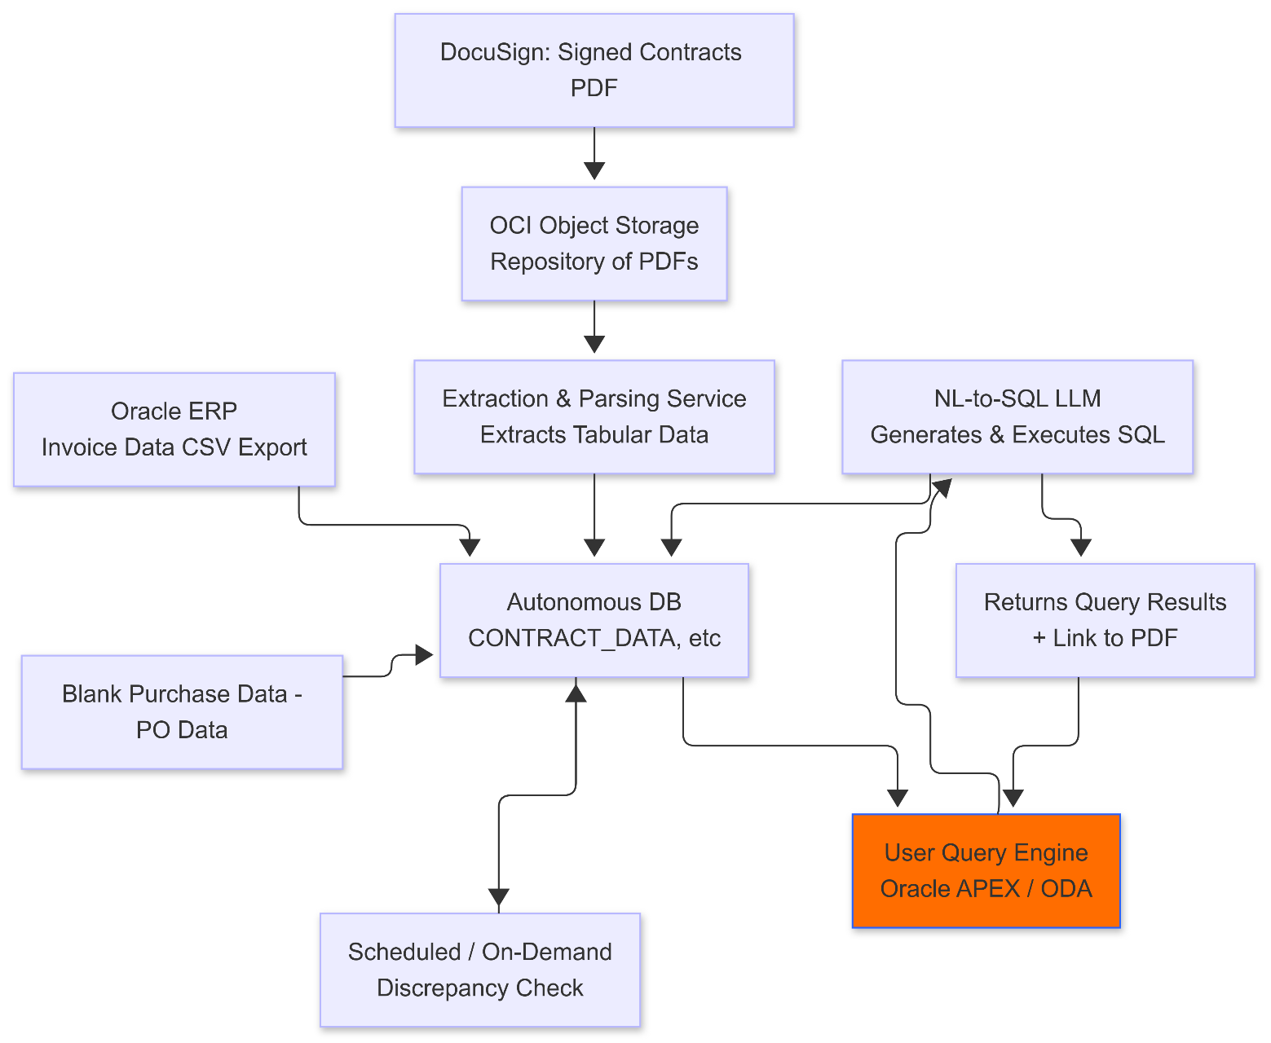

Physical Architecture
The physical architecture for NHS SCCL’s Invoice Price Discrepancy Solution involves clearly defined Oracle Cloud Infrastructure (OCI) components and services arranged as follows:
- Document Storage & Extraction: Oracle Object Storage stores PDFs, with extraction executed via Oracle Compute Instances or Oracle Functions to convert unstructured PDFs into structured data.
- Workflow Automation & Integration: Oracle Integration Cloud (OIC) orchestrates automated document processing and data synchronization between DocuSign, Oracle ERP, extraction engines, and Autonomous Database.
- Centralized Data Management: Oracle Autonomous Database securely stores and manages structured contract, pre-PO, and invoice data, enabling efficient querying and discrepancy detection.
- AI-Powered Querying Interface: Apex-based front-end integrated with Select AI and Gen AI-powered LLM (Llama 3.3 70B model) enables intuitive, natural language querying of structured data.
- User Interface & Security: Oracle Apex provides dashboards and reporting interfaces, securely accessed via Oracle’s Identity and Access Management, ensuring compliance and auditability.

Solution Considerations
The proposed solution emphasizes accurate extraction of critical pricing and contract details from varied PDF documents, which directly impacts the effectiveness and reliability of discrepancy detection. The architecture is designed for scalability, enabling NHS SCCL to handle increasing volumes of invoices and contracts without compromising performance. It also prioritizes stringent adherence to NHS SCCL’s compliance requirements and GDPR regulations, ensuring robust security, controlled access, and comprehensive auditability. Finally, usability is prioritized through an intuitive Oracle Apex interface coupled with natural language querying capabilities, facilitating easy adoption and minimizing user training requirements.

High Availability and Disaster Recovery

For Disaster Recovery (DR), the approach relies primarily on backup and restore mechanisms. There will be no active DR environment deployed during the pilot phase. Instead, data stored in the Oracle Autonomous Database and Oracle Object Storage will be regularly backed up. In case of system failure or significant service disruption, data recovery will be achieved by restoring from backups, ensuring data integrity and continuity with manageable recovery times.

Security
To ensure robust security for the automated document validation solution on Oracle Cloud Infrastructure (OCI), sensitive project data will be protected both at rest and in transit using OCI Key Management for encryption and secure communication protocols such as HTTPS/TLS. Access to the solution will be governed by OCI Identity and Access Management (IAM), which will enforce granular policies, role-based access control (RBAC), and strong authentication mechanisms, including multi-factor authentication (MFA), to ensure only authorized users and services can interact with the system.
The solution components, such as OCI Object Storage and Document Understanding Service, will be deployed within a secure OCI Virtual Cloud Network (VCN) to provide network isolation and prevent unauthorized access. OCI Logging and Monitoring services will be utilized to track all system activities, log access patterns, and detect any suspicious behavior, ensuring real-time visibility and prompt response to potential security incidents. Exposed APIs, such as those for Aconex integration, will be secured using OCI API Gateway, implementing authentication, authorization, and rate-limiting to prevent misuse and unauthorized access.
Regular security audits, compliance checks, and alignment with OCI best practices will ensure the solution adheres to relevant data protection standards and regulatory requirements. Encryption of data stored in OCI Object Storage and controlled access to labeled datasets for model training will further safeguard sensitive project information. These combined security measures ensure a robust, resilient, and compliant solution that protects NHS Construction UK’s data and supports secure, automated document validation processes.

Networking
To ensure seamless connectivity and efficient data transfer for the automated document validation solution on Oracle Cloud Infrastructure (OCI), a reliable and secure network infrastructure will be established using OCI Virtual Cloud Network (VCN). The VCN will create an isolated environment to securely host and connect solution components such as Oracle Integration Cloud (OIC), OCI Object Storage, and OCI Document Understanding Service. Network segmentation will be implemented to isolate critical services and restrict access to only authorized components.
An OCI Service Gateway will facilitate secure communication between the solution components and OCI services, such as Object Storage and Document Understanding Service, without exposing traffic to the public internet. For components requiring private access, OCI Private Endpoints will be configured to ensure secure, internal communication within the VCN. If external access is required for integration with Aconex, appropriate security controls, including firewall rules and network security groups (NSGs), will be enforced to safeguard data transfer.

Sizing and Bill of Materials

Refer to Excel sheet for detailed BoM and Assumptions

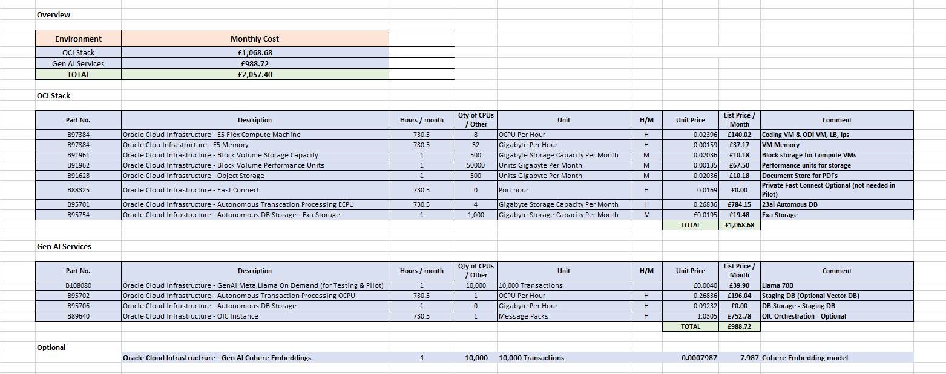

Project Implementation (Only for Oracle Implementations!)

Solution Scope

Disclaimer
As part of the Oracle Lift Services Project, any scope needs to be agreed upon by both the customer and Oracle. A scope can change but must be confirmed again by both parties. Oracle can reject scope changes for any reason and may only design and implement a previously agreed scope. A change of scope can change any previously agreed milestone and needs to be technically feasible.
All items not explicitly stated to be within the scope of the Oracle Lift Services project will be considered out of scope. Oracle recommends the use of professional services to implement extensions or customizations beyond the original scope, as well as to operate the solution, with an Oracle-certified partner.

Overview
- Processing contracting document and compare invoice and PO price(NPC value) against the contract

Business Value
The Oracle Lift Services service brings several benefits to this project. All the activities mentioned within the scope will ensure the deployment of workload as per Oracle's best practices. As a tried and tested methodology by many customers, Oracle Lift services brings the speed of deployment resulting in successful projects without any setbacks. Oracle Lift services will bring value to the overall project provisioning OCI environments for the application workload.
Oracle Cloud Lift services provide guidance from cloud engineers and project managers on planning, project management, architecting, deploying, and managing cloud migrations.

Success Criteria
The below-listed success criteria are for the Oracle Lift services implementation only. Partner activities and success criteria are not listed in this documentation.
- Automatic extraction of key from the contract PDF as in included activities for supplier Johnson and Johnson
- Enables user to view the price discrepancy between contract and Invoice/PO through Apex Page with citation
- Finished handover with documentation
- Complete the Implementation Security Checklist
- <Fusion data price discrepancy check and dashboard>

Workplan

Deliverables
- Solution Definition Document
- Lift Design Document

Included Activities
The implementation scope of work includes the following activities:
OCI Foundation & Network
- OCI Foundation Setup - 1 Region (London)
- OCI Networking configuration
  - Creation of VCN
  - Deployment of standard Security lists and NSG in VCN
  - Deployment of Route Tables in VCNs
- Provision 1 OEL VM to deploy LLM application
- Configure bastion service to allow admin users to connect to the tenancy through the internet access
Security
- Enable Cloud Guard
- Enable Datasafe and Register the Databases in scope

Database
- Provision Oracle Autonomous Transaction Processing (ATP)

Gen AI – LLM Application
- Structured data extraction using Pydantic Model
  - Install required python and Langchain libraries
  - Create a Pydantic model that outlines the expected structure of the output (Supplier name, NPC number, price, customer name, agreement number) and use PDFTabular and PDFmu to extract tabular data
  - Initialize the Pydantic output parser with the defined model.
  - Prompt template to query the LLM and parse its output using the initialized parser.
  - Return structured response that conforms to the specified Pydantic model
  - Expose the python application through API or OCI Functions
  - Meta Llama 3.3 70B (meta.llama-3.3-70b-instruct) text-only model will be used for text extraction
Oracle Integration Cloud (OIC)
- Provision OIC Gen-3 instance
- Configure Trigger and Events to
  - call LLM application to extract key fields from contract PDF documents
  - Update ADW with the extracted fields by LLM application

Select AI
- Create database credential using DBMS_CLOUD.CREATE_CREDENTIAL to securely store LLM keys
- Define AI profile specifying:
  - LLM provider and credential
  - Relevant schemas and contract tables
  - Schema/column comments for improved SQL generation
- Create AI profile in database via DBMS_CLOUD_AI.CREATE_PROFILE
- Set active AI profile with DBMS_CLOUD_AI.SET_PROFILE for user sessions
- Create a package to generate sql using AI profile
- Integrate the package with natural language input interface in APEX
- Integrate natural language input interface in APEX for querying contracts
- Provide query result with citation that includes direct document links (stored in Oracle Object Storage) for easy verification and compliance.
- Conduct testing with sample natural language queries and validate generated SQL/results
Apex
- Enable natural language querying of the contracts in an APEX application with citation
- Configure Page to view price mismatch between the contract data and PO Mismatch data from ADW in following format

Column | Description
Invoice ID | Unique identifier for the invoice.
Total Invoice Price | Sum of all line items in the invoice.
Total PO Price | Sum of all line items in the linked PO.
Sum of Price Diff | Difference between Invoice Price and PO Price (Invoice Price – PO Price).

Show detailed breakdown of discrepancies for a specific invoice

Column | Description
NSVCODE | SKU code
Invoice Price | Price charged in the invoice.
PO Price | Price agreed in the PO.
Fusion Contract Price | Price per the contract (From Blank PO Order Fusion FDI)
Call off Contract Price | (This value should come from PDF)
Invoice ID | Links back to the parent invoice.
PO ID | Linked purchase order.
ContractID | Reference to the governing contract.

- Create users up to 3 for APEX login

API Gateway

- Expose APEX URL through API Gateway

Testing
- Validate the solution with up to 15 Contract documents (Supplier -> Johnson and Jonson)

Pre-requisites

- Supplier Document should be in English PDF format and size less than 500 MB
- Accounts Payable Hold (Invoice) report in Excel
- FDI Reports from Fusion in excel
- Sample contract documents for Testing
- User queries for NLP

Recommended Activities
All items not explicitly stated to be within the scope of the implementation project will be considered out of scope. Oracle recommends the use of professional services to implement extensions or customizations beyond the original scope, or to operate the solution with any of Oracle's certified partners. As a part of this engagement, the below activities are considered to be out of implementation scope.
- Any activities at customer on-premises or existing data center e.g. patching & backups required for migration
- Any integration with other products than in scope
- Any backup and recovery strategy implementation including third-party backup tool implementation
- Application upgrade of any Oracle or other vendor or open source software.
- SSL certificate management and configuration
- Any form of testing and validations, including but not limited to performance testing, load testing, HA testing, DR testing, and tuning of any component in the solution
- Any vulnerability assessment and penetration testing including server hardening, audit certification implementation
- Any functional testing is to be conducted by the customer and/or third party involved
- Any third-party firewall implementation, security tools, monitoring tools implementation
- Troubleshooting existing open issues, including the performance of the application
- Training on deployed products and OCI services
- Run and maintain the support of the environment and end-user training
- Any other data extraction
- Any custom model creation and tuning for document understanding and data extraction
- Any external application integration
- Any SSO configuration
- Any integration with Docusign and EBS
- Any Scheduled / On Demand discrepancy is out of scope
- NLP for APEX Reports
- Role Based access for APEX

Timeline
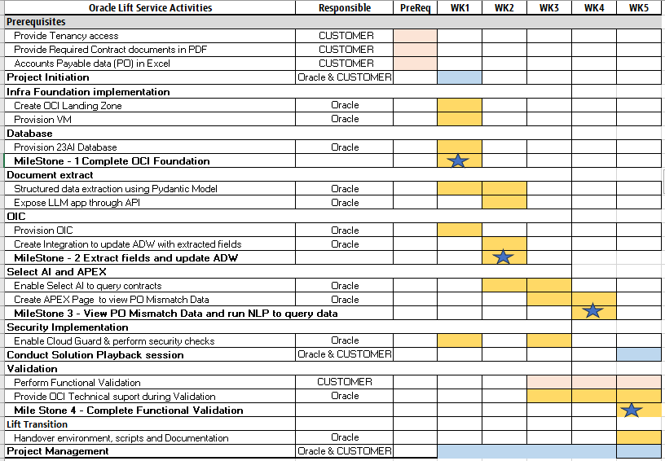

Implementation RACI

Num | Activity | Oracle | Customer
1 | Conduct Project Kickoff | AR | C
2 | Provide access to the source environment | I | AR
3 | Provision Landing Zone | AR | C
4 | Provision 23 AI ATP database | AR | C
5 | Provision OIC | AR | C
6 | Create LLM app to extract structured data from PDF | AR | I
7 | Integrate OIC with ADW and LLM app to update extracted fields | AR | I
8 | Select AI for NLP to query contract details | AR | I
9 | Create Apex Page to view PO Mismatch data | AR | I
10 | Create Apex Page to query contract document for select AI | AR | I
11 | Perform validation within the project timeline | I | AR
12 | Provide OCI technical support during validation | AR | C
13 | Provide access to My Oracle Support required for product support along with CSI number | I | AR
R- Responsible, A- Accountable, C- Consulted, I- Informed

Assumptions
Generic assumptions
- It is assumed that all required contractual agreements between Oracle and the Customer are in place to ensure uninterrupted execution of the project.
- It is assumed that all work will be done remotely and within either central European time or India Standard Time normal office working hours.
- It is assumed that upgrades are excluded from the scope of work and no production systems/production cutover is part of the scope of work undertaken by the Oracle Service
- It is assumed that all required Oracle cloud technical resources are available for use during the duration of the project and that engineers involved have been granted the appropriate access to those technical resources by the customer before the start of the project.
- It is assumed that all required customer resources, and if applicable third-party resources, are available during the duration of the project to work openly and collaboratively to realize the project goals uninterruptedly.
- It is assumed that all required customer resources, and if applicable third-party resources are aware of all technical and non-technical details of the as-is and to-be components. All resources are committed to technical work as far as is needed for the execution of the project.
- It is assumed that all required documentation, system details, and access needed for the execution of the project can be given/granted to parties involved when and where deemed needed for the success of the project.
- It is assumed that the customer will have adequate licenses for all the products that may/will be used during the project and that appropriate support contracts for those products are in place where the customer will take the responsibility of managing any potential service request towards a support organization to seek resolution of a problem.
- It is assumed the customer will provide the appropriate level of information and guidance on rules and regulations which can directly and/or indirectly influence the project or the resulting deliverables. This includes, however not limited to, customer-specific naming conventions, security implementation requirements, internal SLA requirements as well as details for legal and regulatory compliance. It will be the responsibility of the customer to ensure that the solution will adhere to this.
- It is assumed that under the customer's responsibility, the customer will ensure and validate that the solution will be placed under the proper controls for ensuring business continuity, system availability, recoverability, security control, and monitoring and management as part of a post-project task.
- It is assumed that the customer will take responsibility for testing all functional and non-functional parts of the solution within the provided timeline and ensure a proper test report will be shared with the full team (including customer, Oracle, and if applicable third party).
- It is assumed that any requirement, deliverable, or expectation that is not clearly defined as in-scope of the project will not be handled as part of the project and is placed under the responsibility of the customer to be handled outside of the project.
Project-specific assumptions
- Document will be provided in English PDF(No Image) and size should be less than 1 MB.
- Contract document should be human readable for column extraction (No Truncation/Overlap of fields)
- NPC is unique across contracts
- The NSV Code in the Fusion Data Excel file serves as a unique identifier that links to the NPC Column in the PDF document. It is used to join data between these two sources
- There are no amendments in contract with the same reference number

Obligations
- The customer’s tenancy has required subscription attached to it and has access to the needed OCI services to implement the use case.
- The implementation team will have admin access to the customer's tenancy for implementation.
- You will ensure the appropriate product training has been obtained to maintain and support the implementation
- Your business team will be available for the Testing phase, which will be completed within the agreed testing window.
- You will provide project management for the project and will manage any third-party suppliers or vendors.
- You will revoke implementor access on production goLive or after project completion.
- You will take consistent and restorable backups of your existing data and application before implementation.

Transition Plan

Introduction
Following the deployment of the solution to Oracle Cloud Infrastructure by the Oracle Lift Services team, it is important to ensure a smooth handover to a technical team, or a partner. Oracle Lift Services values the continuation of the cloud journey and we focus our efforts to ensure you start with the best possible foundation, to set you up for success in OCI.
When Oracle Lift Services completes the deliverables as described in the Workplan section of this document, Oracle Lift Services will hand over the controls of the new OCI environment.
NHS , or a partner of your choice, will assume the ownership of the OCI tenancy and responsibility for further development of the OCI environment. From that moment forward, having completed the Solution Scope, Oracle Lift Services will disengage. For post-implementation support, Oracle provides you with three distinct resources:
- Oracle Account Cloud Engineer (ACE) – This is your first point of contact and will provide technical leadership and support for Oracle cloud technologies and your cloud transformation.
- Cloud Adoption Manager (CAM) - Introduces and plans operation monitoring and optimization advisory activities, and continues working with you on the next milestones. Please contact your ACE for further information.
- My Oracle Support

Transition Acceptance
When Oracle Lift Services completes the deliverables as specified in the Workplan section of this document, a closure session will be scheduled within 1-2 weeks to recap the project and to hand it over to the accepting party. In the case of this project, the accepting party is NHS . NHS is now responsible for the OCI tenancy.
From this moment forward, the Oracle Lift Services team will fully remove their access from your OCI tenancy and provide the access credentials to the accepting party. This marks the completion of the Oracle Lift Services project. There is no sign-off signature required.

Annex

Security Guidelines

Oracle Security, Identity, and Compliance
Oracle Cloud Infrastructure (OCI) is designed to protect customer workloads with a security-first approach across compute, network, and storage – down to the hardware. It’s complemented by essential security services to provide the required levels of security for your most business-critical workloads.
- Security Strategy – To create a successful security strategy and architecture for your deployments on OCI, it's helpful to understand Oracle's security principles and the OCI security services landscape.
- The security pillar capabilities reflect fundamental security principles for architecture, deployment, and maintenance. The best practices in the security pillar, help your organization to define a secure cloud architecture, identify and implement the right security controls, and monitor and prevent issues such as configuration drift.

References
- The Best Practices Framework for OCI provides architectural guidance about how to build OCI services in a secure fashion, based on recommendations in the Best practices framework for Oracle Cloud Infrastructure.
- Learn more about Oracle Cloud Security Practices.
- For detailed information about security responsibilities in Oracle Cloud Infrastructure, see the Oracle Cloud Infrastructure Security Guide.

Compliance and Regulations
Cloud computing is fundamentally different from traditionally on-premises computing. In the traditional model, organizations are typically in full control of their technology infrastructure located on-premises (e.g., physical control of the hardware, and full control over the technology stack in production). In the cloud, organizations leverage resources and practices that are under the control of the cloud service provider, while still retaining some control and responsibility over other components of their IT solution. As a result, managing security and privacy in the cloud is often a shared responsibility between the cloud customer and the cloud service provider. The distribution of responsibilities between the cloud service provider and the customer also varies based on the nature of the cloud service (IaaS, PaaS, SaaS).

Additional Resources
- Oracle Cloud Compliance – Oracle is committed to helping customers operate globally in a fast-changing business environment and address the challenges of an ever more complex regulatory environment. This site is a primary reference for customers on the Shared Management Model with Attestations and Advisories.
- Oracle Security Practices – Oracle’s security practices are multidimensional, encompassing how the company develops and manages enterprise systems, and cloud and on-premises products and services.
- Oracle Cloud Security Practices documents.
- Contract Documents for Oracle Cloud Services.
- OCI Shared Security Model
- OCI Cloud Adoption Framework Security Strategy
- OCI Security Guide
- OCI Cloud Adoption Framework Security chapter

Networking Requirement Considerations
The below questions help to identify networking requirements.

Application Connectivity
- Does your application need to be exposed to the internet?
- Does your solution on DC (on-prem) need to be connected 24x7 to OCI in a Hybrid model?
  - Site-to-Site IPSEC (Y/N)
  - Dedicated Lines (FC) (Y/N)
- Are there any specific network security requirements for your application? (No internet, encryption, etc, etc)
- Will your application require connectivity to other cloud providers?
  - Site-to-Site IPSEC (Y/N)
  - Dedicated Lines (FC) (Y/N)
- Will your application require inter-region connectivity?
- Are you planning to reuse IP addresses from your on-premises environment in OCI?
- If yes, what steps have you taken to ensure IP address compatibility and avoid conflicts?
- How will you handle network address translation (NAT) for IP reuse in OCI?
- Will you bring your own public IPs to OCI?

DR and Business Continuity
- Does your organization need a Business Continuity/DR Plan to address potential disruptions?
  - Network Requirements (min latency, bandwidth, etc)
  - RPO/RTO values
- What are your requirements regarding Data Replication and Geo-Redundancy (different regions, restrictions, etc.)?
- Are you planning to distribute incoming traffic across multiple instances or regions to achieve business continuity?
- What strategies do you require to guarantee minimal downtime and data loss, and to swiftly recover from any unforeseen incidents?

High Availability and Scalability
- Does your application require load balancing for high availability and scalability? (y/n)
  - Does your application span around the globe or is regionally located?
  - How do you intend to ensure seamless user experiences and consistent connections in your application (session persistence, affinity, etc.)?
  - What are the network Security requirements for traffic management (SSL offloading, X509 certificates management, etc.)?
  - Does your application use name resolutions and traffic steering across multiple regions (Public DNS steering)?

Security and Access Control
- Are you familiar with the concept of Next-Generation Firewalls (NGFW) and their benefits over traditional firewalls?
- Have you considered the importance of protecting your web applications from potential cyber threats using a Web Application Firewall (WAF)?

Monitoring and Troubleshooting
- How do you plan to monitor your application's network performance in OCI?
- How can you proactively address and resolve any potential network connectivity challenges your company might face?
- How do you plan to troubleshoot your network connectivity?

Networking Solutions

OCI Network Firewall
Oracle Cloud Infrastructure Network Firewall is a next-generation managed network firewall and intrusion detection and prevention service for your Oracle Cloud Infrastructure VCN, powered by Palo Alto Networks®.
- Overview
- OCI Network Firewall

OCI Load Balancer
The Load Balancer service provides automated traffic distribution from one entry point to multiple servers reachable from your virtual cloud network (VCN). The service offers a load balancer with your choice of a public or private IP address and provisioned bandwidth.
- Load Balancing
- Overview
- Concept Overview

OCI DNS Traffic Management
Traffic Management helps you guide traffic to endpoints based on various conditions, including endpoint health and the geographic origins of DNS requests.
- Concept Overview
- DNS

OCI WAF
Protect applications from malicious and unwanted internet traffic with a cloud-based, PCI-compliant, global web application firewall service.
- Cloud Security Web Application Firewall
- Add WAF to a load balancer

OCI IGW
An internet gateway is an optional virtual router that connects the edge of the VCN with the internet. To use the gateway, the hosts on both ends of the connection must have public IP addresses for routing
- Managing IGW

OCI Site-to-Site VPN
Site-to-site VPN provides a site-to-site IPSec connection between your on-premises network and your virtual cloud network (VCN). The IPSec protocol suite encrypts IP traffic before the packets are transferred from the source to the destination and decrypts the traffic when it arrives. Site-to-Site VPN was previously referred to as VPN Connect and IPSec VPN.
- Overview IPSec
- Setup IPSec

OCI Fast Connect
FastConnect allows customers to connect directly to their Oracle Cloud Infrastructure (OCI) virtual cloud network via dedicated, private, high-bandwidth connections.
- FastConnect
- Concept Overview

OCI VTAP
A Virtual Test Access Point (VTAP) provides a way to mirror traffic from a designated source to a selected target to facilitate troubleshooting, security analysis, and data monitoring
- VTAP
- Network VTAP Wireshark

OCI NPA
Network Path Analyzer (NPA) provides a unified and intuitive capability you can use to identify virtual network configuration issues that impact connectivity. NPA collects and analyzes the network configuration to determine how the paths between the source and the destination function or fail.
- Path Analyzer

OCI DRG (Connectivity Options)
A DRG acts as a virtual router, providing a path for traffic between your on-premises networks and VCNs, and can also be used to route traffic between VCNs. Using different types of attachments, custom network topologies can be constructed using components in different regions and tenancies.
- Managing DRGs
- OCI Pilot Light DR
- Peering VCNs in different regions through a DRG

OCI Oracle Cloud Infrastructure Certificates
Easily create, deploy, and manage Secure Sockets Layer/Transport Layer Security (SSL/TLS) certificates available in Oracle Cloud. In a flexible Certificate Authority (CA) hierarchy, Oracle Cloud Infrastructure Certificates help create private CAs to provide granular security controls for each CA.
- SSL TLS Certificates

OCI Monitoring
You can monitor the health, capacity, and performance of your Oracle Cloud Infrastructure resources by using metrics, alarms, and notifications. For more information, see Monitoring and Notifications.
- Networking Metrics

